API Design Best Practices

Fuse (Camel), Data Virtualization, and Feedhenry

# Table of Contents

Table of Contents 2

1. APIs & the Enterprise 3

1.1. APIs vs. More Traditional SOA Approaches 3

1.2. Challenges in developing and consuming APIs 4

1.3. How JBoss tools make developing APIs simple 4

1.3.1. Creating an API with JBoss Developer Studio (JBDS) 4

1.3.2. Creating a Virtual Database with JDBS 7

2. Security – Authentication, Authorization 10

3. API publishing – Versioning, provisioning 18

4. Middleware connectors and ESB integration 21

5. API for Independent Web Services 24

6. Mediation – Message Validation, Message Transformation 27

7. Productization –Third party API integration 31

7.1. A-MQ Connector 31

7.2. Salesforce 32

7.3. Twitter 35

8. Certification and testing 38

9. Data services – Direct data access, Meta data services 39

10. Business intelligence 48

11. Feedhenry Integration: 49

12. Appendix 53

13. References 54

# APIs & the Enterprise

What are APIs (Application Programming Interfaces)? What is new about them? Aren’t they just a newer version of SOA, which has been around for a long time? The concept of an API is not new; Linux, Windows, C, and Java all had APIs since their inception that were typically compiled into the user’s application code and are executed in the user’s computer.

|  |  |  |
| --- | --- | --- |
| API Category | Example | Timeline |
| Operating System | API for MS Windows  API for Apple Mac OS X (Cocoa) | 1985-  2001- |
| Programming Languages | Java API | 1995- |
| Application Services | API for SAP (BAPI) | 1990s- |
| Infrastructure Services | Amazon Web Services API | 2002- |
| Web Services | Twitter API | 2006- |

What is new is the rise and dramatic proliferation of lightweight public APIs, and the rapid expansion of these into enterprise applications. Today, enterprises are able to quickly build and maintain complex applications that orchestrate across public and private APIs to provide business users with the unified capabilities that they demand. Enterprise customers, suppliers, and partners are also demanding access to enterprise APIs to leverage within their own applications. So as an architect, it is important to understand and be able to resolve the unique challenges inherent both in building composite applications and in deploying APIs for public consumption.

While it is true, that there are many similarities when designing applications to use lightweight APIs and using more traditional approaches, there are some unique differences. This white paper is intended help developers and application architects understand some of these differences and to help them to take advantage of the benefits of these technologies. The key objectives of this white paper are to:

* Explain what makes lightweight APIs different from more traditional approaches such as SOAP (Simple Object Access Prototocol)
* Identify and provide solutions to some of the common design and development challenges when implementing APIs
* Demonstrate the use of JBoss tools and technologies to quickly build a working API demo that showcases these development approaches
* Help you understand when and where to use which approach

## APIs vs. More Traditional SOA Approaches

How are APIs different from the more traditional SOA approaches such as SOAP? First, it is important to understand that SOAPis really an API.However, the use of SOAP is based on a design contract (i.e., a WSDL) and provided using a highly structured XML document. Other applications (either directly or through the ESB) consume services according to the contract. Although the concept of the WSDL was intended to provide an open API that could be leveraged by any consumer, in practice SOAP became used primarily in point-to-point integrations.

What really distinguished APIs (as we use the term today) from the more traditional SOA approach was the introduction of lightweight web APIs. These lightweight APIs operate over a network through the HTTP protocol, using REST-style communication to access a remote resource or service. The responses are typically expressed in JSON or XML (RSS, Atom). The advent of lightweight APIs solved some of the key challenges of the more traditional SOA approaches such as SOAP. These small APIs could be developed very quickly, had a much smaller network footprint than SOAP, and could be consumed easily by everything from a full-fledged enterprise application to a web browser running javascript or by mobile applications. These lightweight APIs have exploded into the marketplace, and are driving what is now called the “Internet of Things”, where in the next few years virtually all new devices will be connected in some way.

## Challenges in developing and consuming APIs

APIs are lightweight, easy to build and consume, so end of story, right? Yes, APIs can be easy to build and consume, but to do this well, one must consider many of the same architectural issues that are found in any enterprise development program: is my API usable, does it scale, is it maintainable, is it secure, etc. Addressing all of these concerns is the subject of a book, not a white paper such as this one! What we would like to demonstrate is how to solve some of the most common business and technical problems when developing with APIs. For example, developers often face issues such as:

* How to secure an API
* How to integrate with Salesforce.com
* How to leverage social media (such as Twitter) from my application
* How to integrate and display data from multiple data sources

For this white paper, we have chosen various problems that cover a variety of different development challenges, and will be leverage JBoss Fuse and Camel and Data Virtualization to address these challenges. The details and how to access the code samples can be found in the appendix. We hope that the examples in the next sections will be useful in jumpstarting your API program!

## How JBoss tools make developing APIs simple

JBoss tools such as JBoss® Developer Studio provides superior support for your entire development lifecycle. They include a broad set of tooling capabilities and support for multiple programming models and frameworks, including Java™ Enterprise Edition 6, RichFaces, JavaServer Faces (JSF), Enterprise JavaBeans (EJB), Java Persistence API (JPA), and Hibernate®, JAX-RS with RESTEasy. They support Context Dependency Injection (CDI), HTML5, and many other popular technologies, and provide the developer choices in supporting multiple JVMs, productivity with Maven, and in testing with Arquillian. They are also fully tested and certified to ensure that the plug-ins, runtime components, and their dependencies are compatible with each other.

### Creating an API with JBoss Developer Studio (JBDS)

JBoss Developer Studio includes both certified visual tooling and the production-ready, fully supported Red Hat JBoss Enterprise Application Platform, which is supported by Red Hat for as part of a subscription. With a simple point and click interface, JBoss Developer Studio makes creating APIs simple. For example, perhaps you have created an API and would now like to add a component that fires a query to a database. With JBDS, this is a quick 3-step process:

1. add a logging component and configure it to log as desired
2. add a dynamic router
3. configure the router to pass the request to the database handler

The details are shown in the below figures. In this case, we are starting with a simple route. In Figure 1, we have started with a simple route, and have just added the “log” element on the right. In the subsequent figures we add and configure the dynamic router to route the generated log messages to the database.

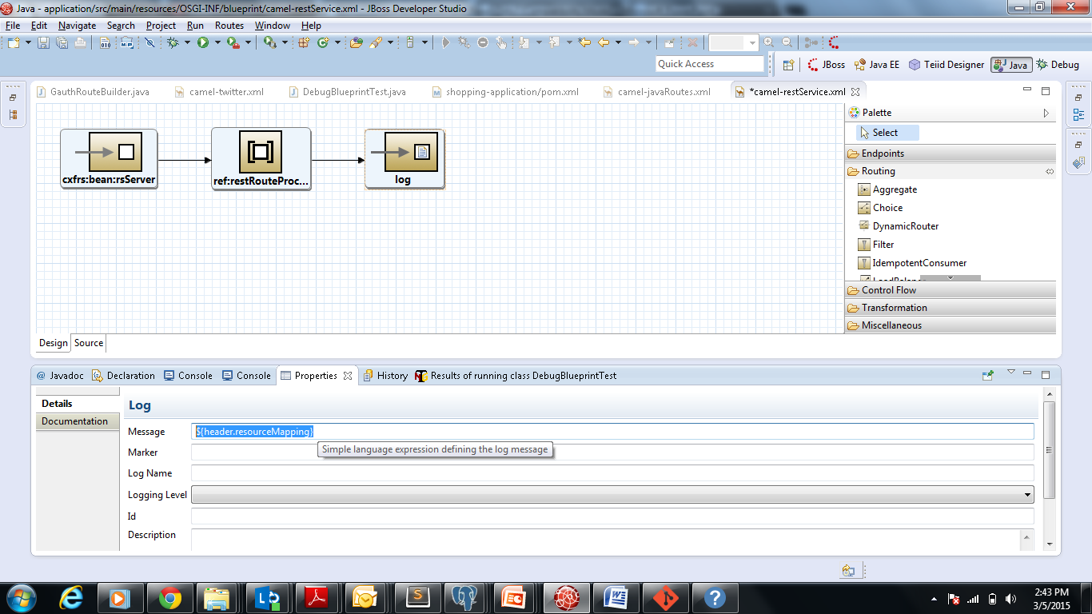

Figure . Add a logging component and configure it

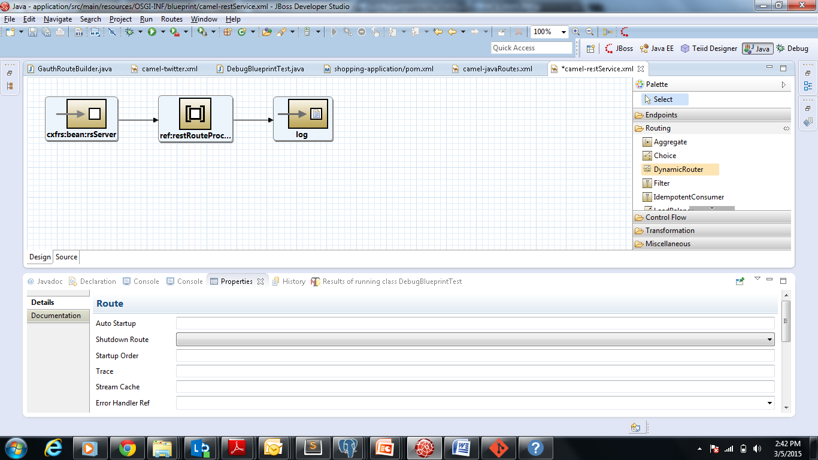

Figure . Add a dynamic router

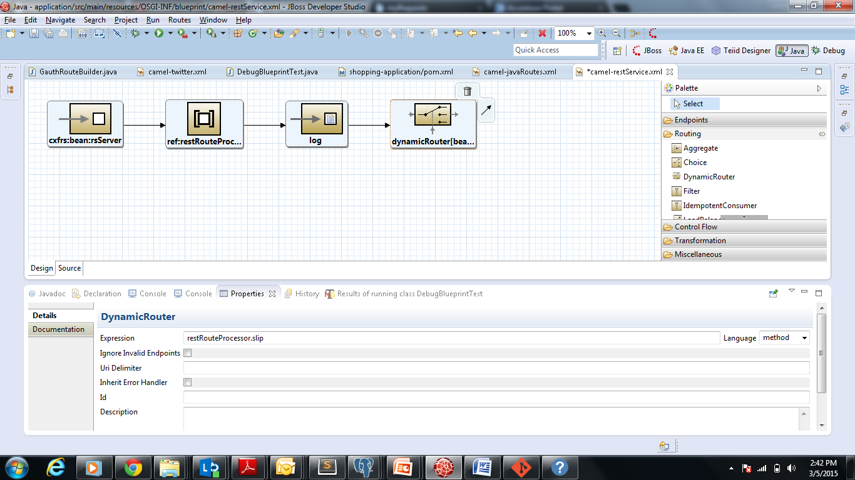

Figure . Configure the router

The configuration of the router maps the incoming request to the appropriate database handler service. This mapping is programmatically generated and is present in the restRouteProcessor.slip expression.

To configure the database connection we need to add the JDV server as a data-source in our application. This configuration is added as a spring bean in the beans.xml

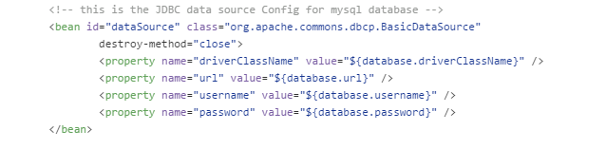

Figure . Add the data source to Spring configuration

The default configuration of the data source properties are present under projects/shopping-demo-application/application-interface/src/main/resources/shoppingApplication.properties file.

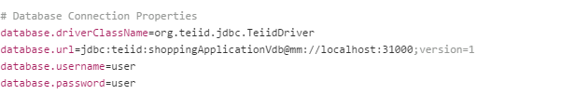

Figure . Configure the database driver

To override these properties it is recommended to update the dv-support/application.properties file.

Once the database configuration we can now add a route to process the request forwarded by the Dynamic Router. Below is the route:

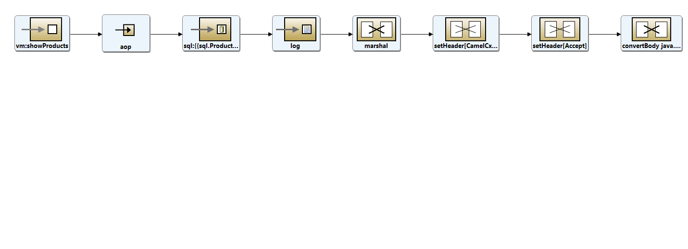

Figure . Add the new route

The sql query is fired by the sql component in the route. Camel as many built in components to connect to different data sources. To use the sql component we just need to add the component in the application as a bean and link the component to the data source.

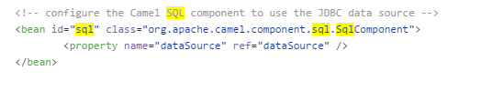

Figure . Configure Camel to use the data source

### Creating a Virtual Database with JDBS

Data virtualization allows an application to retrieve and manipulate data without requiring technical details for the underlying data sources. Creating a virtual database from multiple data sources is simple as well. Using the Teiid Designer within JDBS, this becomes a straightforward set of point and click steps. Teiid Designer is a visual tool that enables rapid, model-driven definition, integration, management and testing of data services without programming using the Teiid runtime framework. With Teiid Designer, not only do you create source data models and map your sources to target formats using a visual tool, but you can also:

* create a virtual database (or VDB) containing your models which you deploy to Teiid server and then access your data.
* resolve semantic differences
* create virtual data structures at a physical or logical level
* use declarative interfaces to integrate, aggregate, and transform the data on its way from source to a target format which is compatible and optimized for consumption by your applications

The set of figures below illustrate how to do this once the initial data sources are configured. For details on configuring the datasources and exposing this within your application, see **Section 9**.

With the underlying databases already configured, the first step in creating a virtual database is to go to the File Menu and create a new Teiid VDB.

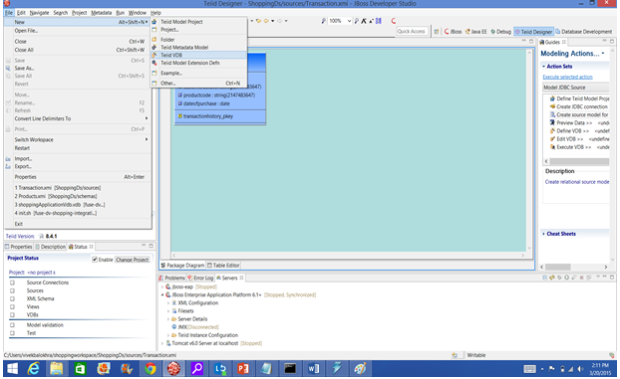

Figure . Creating a new Teiid VDB

The new VDB asks for models. We simply click on the Add button to add these to our VDB.

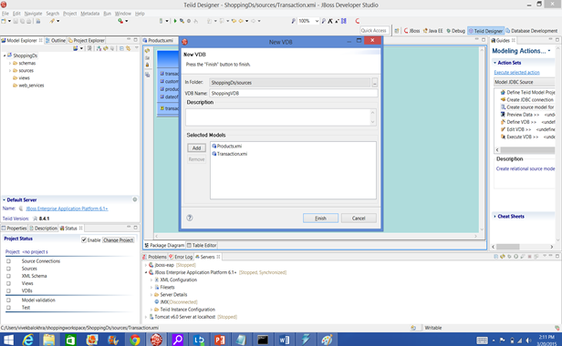

Figure . Adding the previously created models

The virtual database ShoppingVDB.vdb is now ready for use in your application. Further details are available in **Section 9**.

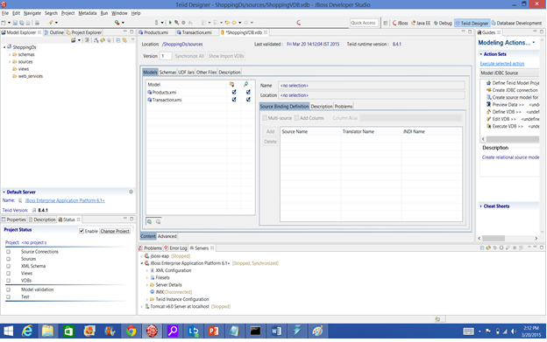

Figure . The newly created ShoppingVDB.vdb

# Security – Authentication, Authorization

Authentication and Authorization are likely to be the most common use cases that an API developer will run across. Almost every application that is developed requires a user to prove who they are, that they should have access to the requested resource and what they are allowed to do.

***Authentication*** is the process of ensuring that an entity in a system transaction (including users, servers, and clients) is who he, she, or it claims to be. Typically, authentication happens when a user logs into a system or application.

***Authorization Services*** implement policies that restrict access to given resources (e.g.: only some users may be authorized to read the salary information of an employee). Authorization Services leverage Authentication Services to identify the user/application requiring the service. Generally, Authorization Services are "role-based", thus access rights to a service are assigned to roles (or groups) instead of users.

Typically, authentication and authorization are NOT provided by the API developer (or end-user applications for that matter). Authentication and authorization are provided by ***endpoint security*** components within the Camel framework. These endpoint security components secure the “endpoints” – i.e. specific URLs, as well as offer the ability to secure the API payloads.

Almost all enterprise applications leverage some form of central authentication or authorization. Increasingly, consumer facing web applications and APIs do the same, often leveraging common providers such as Facebook or Google to allow users to authenticate using a common set of credentials.

There are many camel components that support endpoint security. Some of the more commonly used include:

|  |  |
| --- | --- |
| Camel Component | Use Case |
| JMS and ActiveMQ | SSL/TLS security and JAAS security for client-to-broker and broker-to-broker communication |
| Jetty | HTTP Basic Authentication and SSL/TLS security |
| CXF | SSL/TLS security and WS-Security |
| Crypto | creates and verifies digital signatures in order to guarantee message integrity |
| Netty | SSL/TLS security |
| MINA | SSL/TLS security |
| Cometd | SSL/TLS security |
| glogin and gauth | authentication in the context of Google applications |

As you build and deploy enterprise APIs, you are likely to encounter many different standards for authentication and authorization. In reality – there is no “right” answer for which one to use, except to use the one that is standard within your enterprise.

Camel offers several forms & levels of security capabilities that can be utilized on camel routes. These various forms of security may be used in conjunction with each other or separately.

The broad categories offered are

1. **Route Security** - Authentication and Authorization services to proceed on a route or route segment These capabilities are offered by the following components:
2. [1][Shiro Security](http://camel.apache.org/shiro-security.html)
3. [Spring Security](http://camel.apache.org/spring-security.html)[2]
4. **Payload Security** - Data Formats that offer encryption/decryption services at the payload level. These capabilities are offered by the following components:
5. [XMLSecurity DataFormat](http://camel.apache.org/xmlsecurity-dataformat.html)[3] (XML Encryption support)
6. [XML Security component](http://camel.apache.org/xml-security-component.html)[4] (XML Signature support)
7. [Crypto DataFormat](http://camel.apache.org/crypto.html)[5] (Encryption + PGP support)
8. [Crypto component](http://camel.apache.org/crypto-digital-signatures.html)[6] (Signature support)
9. **Endpoint Security** - Security offered by components that can be utilized by the endpoint URIs associated with the component. Some such components are:
10. [Jetty](http://camel.apache.org/jetty.html)[7] - HTTP Basic Authentication support * SSL support
11. [CXF](http://camel.apache.org/cxf.html)[8] - HTTP Basic Authentication & WS-Security support using the CXF Bus driven interceptor chain
12. [Spring Web Services](http://camel.apache.org/spring-web-services.html)[9] - HTTP Basic Authentication & WS-Security support
13. [Netty](http://camel.apache.org/netty.html)[10] - SSL support
14. [MINA](http://camel.apache.org/mina.html)[11] - SSL support
15. [Cometd](http://camel.apache.org/cometd.html)[12] - SSL support
16. [JMS](http://camel.apache.org/jms.html)[13] - JAAS and SSL based security for client <--> broker communication
17. **Configuration Security** - Security offered by encrypting sensitive information from configuration files. Camel offers the [Properties](http://camel.apache.org/properties.html) component to externalize configuration values to properties files. Those values could contain sensitive information such as usernames and passwords. Those values can be encrypted and automatic decrypted by Camel

The role of fuse in the authentication process of the application is to integrate the authentication service providers (LDAP,database,o-auth) to our application. Validating the authenticated user can be done in the Web app layer using filters as well. However linking the authentication providers as a service in the integration layer is a better practice to add flexibility to the design.

Linking in such a way also makes the services readily available to front-end frameworks like Angular which can now directly link to the integration layer. However if the authentication process is coupled with the Web-app layer the requests have to necessarily pass through the Web-app layer.

In case a web app layer is mandatory in the application we can always expose the fuse security route as a service to the web-app layer.

For this white paper, demonstrating enterprise authentication would be difficult as there are a wide variety of authentication providers, and we can’t really stand up all of them in a simple demo. So instead, we have focused on a more consumer-oriented solution – integrating with Google. We have chosen to use the gauth component in our shopping cart application. The user experience when using gauth is fairly straightforward as shown in the figures below.

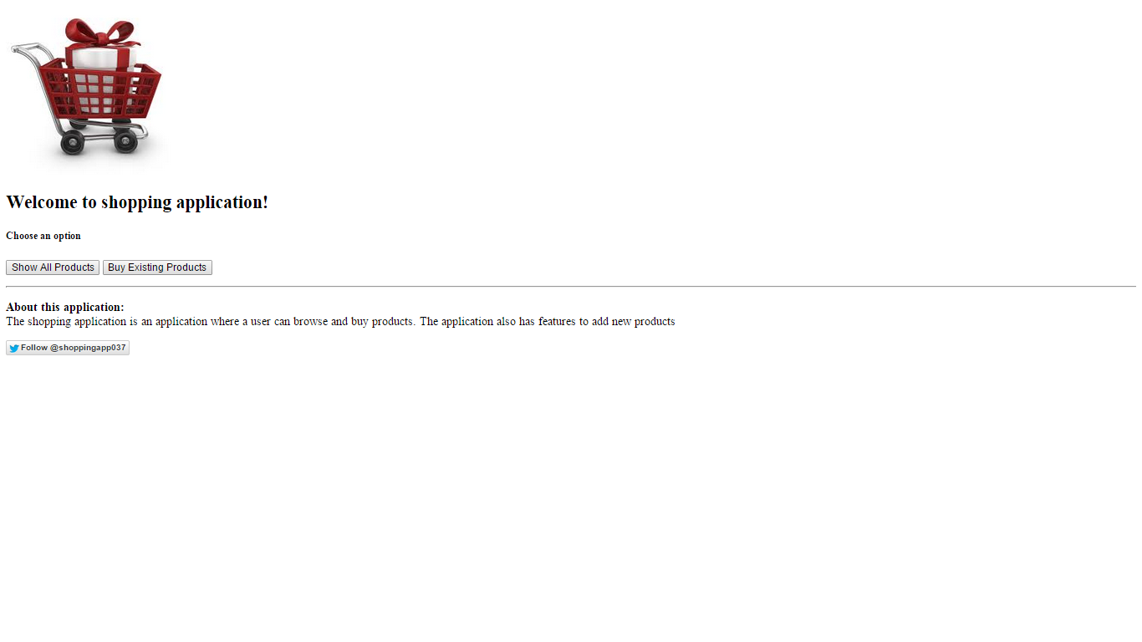

Figure . User browses to the application and clicks buy

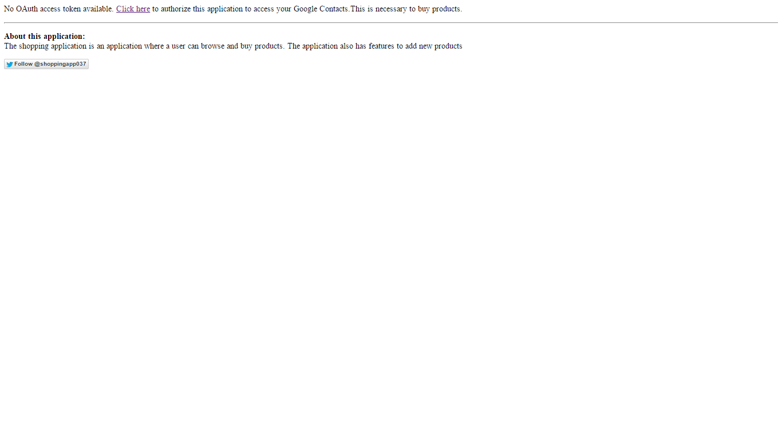

Figure . Application displays a request to authenticate via Google

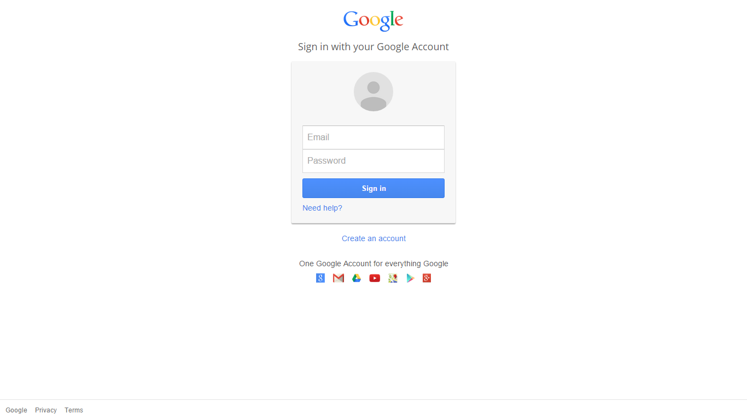

Figure . User is directed to the Google Authenticator to login

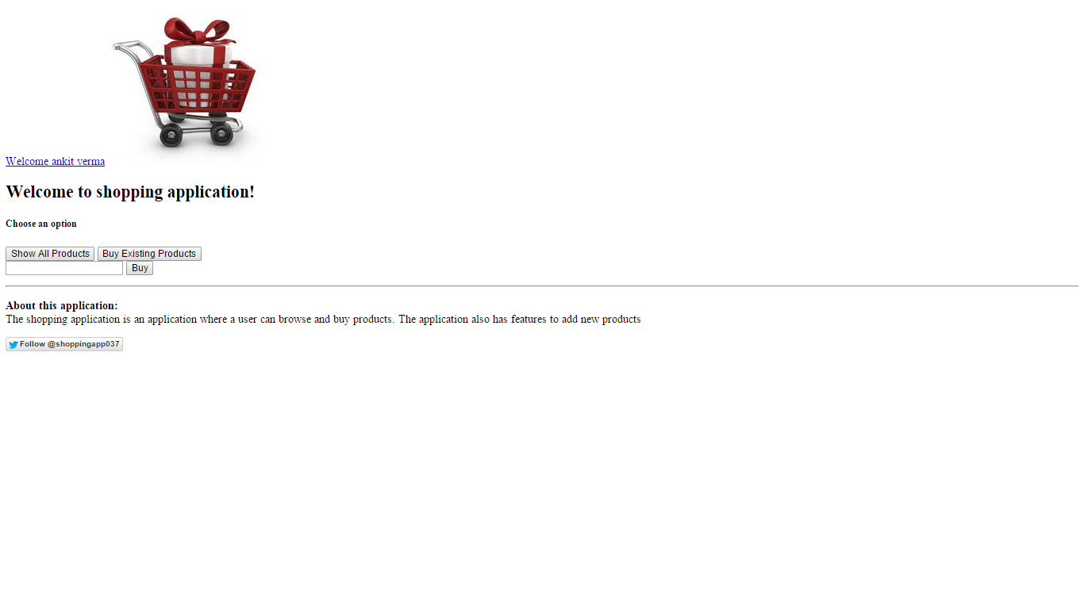

Figure . Once logged in, the user sees the full experience

Fuse makes simple to implement these steps. The approach we have taken is to create a Camel route named **GauthRouteBuilder** (see Figure 19. GauthRouteBuilder) In the GauthRouteBuilder:

1. On clicking the buy products a cookie is checked. If the cookie is not found the GET request to /shoppingApplication/application/authenticate will trigger the OAuth sequence of interactions.
2. The request is handled by a spring based controller which redirects the request to the CamelHttpTransportServlet. This servlet is responsible to forward the request to the GauthRouteBuilder.
3. The gauth: authorize endpoint obtains an unauthorized request token from Google and then redirects the user (browser) to a Google authorization page.
4. After the user logs in successfully to Google, the user is redirected back to /shoppingApplication/camel/handler (using the callback URL) along with an authorized request token.
5. The gauth: access endpoint exchanges the authorized request token against a long-lived access token.
6. The access token can be obtained from:

exchange.getOut().getHeader(

GAuthUpgradeBinding.GAUTH_ACCESS_TOKEN)

1. The access token secret can be obtained from

exchange.getOut().getHeader(

GAuthUpgradeBinding.GAUTH_ACCESS_TOKEN_SECRET)

1. The token values are then saved as a cookie by TokenProcessor. It also forwards the request to /shoppingApplication/application/postAuthenticate
2. The post authentication request is handled by a spring controller which then stores the details of the user logged in as a session attribute. It uses the TokenLoginService class to fetch user details.

**Understanding the gauth beans wiring:**

Below are the beans we have created to use gauth functionality .

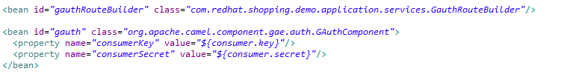

Figure . beans.xml

These beans are available at application-interface/../resources/camel/camel-AuthContext.xml. All the xmls within the resources/camel folder are loaded by the spring container. This configuration is provided in the application-interface/../resources/WEB-INF/web.xml file by adding the contextConfigLocation parameter to the application and spring context loader listener. Below is the configuration:

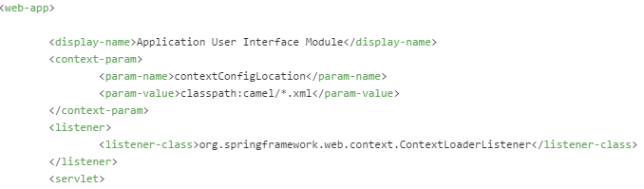

Figure . web.xml

The beans are set with values read from the resources/shoppingApplication.propertiesfile



Figure . shoppingApplication.properties

Once the beans are created the gauth and camel-servlet components are loaded. Any camel route in our application can now use ghttp as an end point. Finally the gauthRouteBuider bean is added to a camel context where we are specifying it as a camel route. This configuration is done in camel-AuthContext.xml:

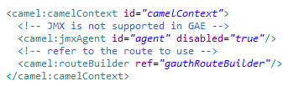

Figure . camel-AuthContext.xml.xml (continued)

**Understanding the Router:**

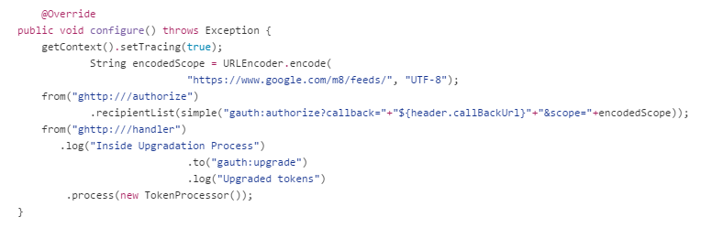

Figure . GauthRouteBuilder

The router is invoked by the camel servlet and once the tokens are fetched they are saved as cookies by the TokenProcessor.

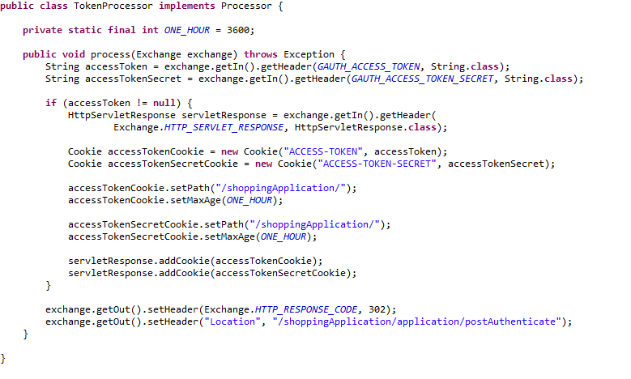

Figure . TokenProcessor

Once the cookies are created the request is redirected to /shoppingApplication/application/postAuthenticate. The ApplicationController handles the requests and uses the TokenLoginService to set user details in the current session

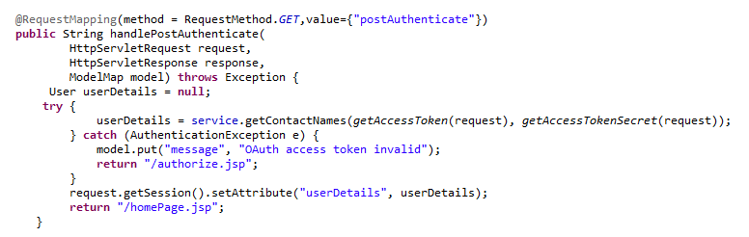

Figure . ApplicationController

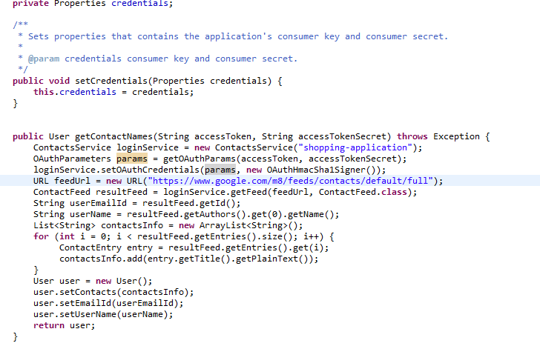

Figure . TokenLoginService

# API publishing – Versioning, provisioning

Versioning of APIs is a critical concern that must be addressed when deploying your APIs. Once your API is deployed, you have minimal control over who consumes it. Changing the API contract can break all of the downstream applications that use it. Imagine if Twitter changed their API – how many web sites and mobile applications would break? And yet, applications must evolve over time. How do we meet the competing demands of updating and adapting to changing needs, while not breaking all of our application consumers? One way is through a consistent approach to version control of our APIs. Our recommendation is that all APIs should be versioned from the very start, providing clear direction to our consumers of how we plan to update our services.

“Name” versioning is the recommended approach to versioning of APIs. The version is represented in the URI itself. This represents the de facto standard approach. When providing versioning in the URI it should use the following format vX where X is an integer begin with 1. Some examples are:

**http://example.com/api/v2**

**http://api.example.com/v2/resource**

**http://apiv2.example.com/resource**

In our Shopping Application we have included versioning when we build, install and deploy it as OSGI bundle. The OSGI command which includes versioning too:

osgi:install -s war:mvn:com.redhat/application-interface/1.0.0-SNAPSHOT/war?Web-ContextPath=<version>/shoppingApplication

The version changes are respectively made by editing the run.sh file in our project folder.

We add the <warName> tag under <plugins> tag under the application’s pom.xml. This <warName> tag specifies the pattern used for webContextPath. The webContextPath is called in run.bat .

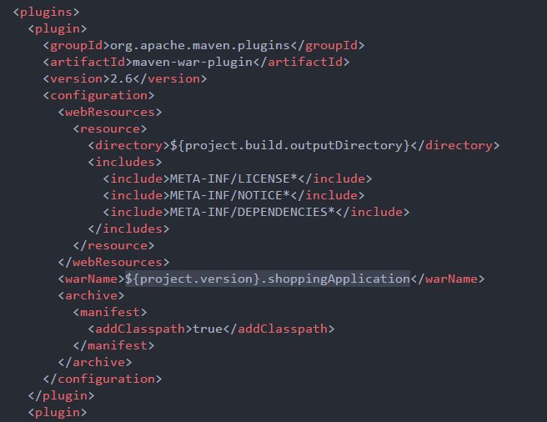

Figure19. Configuring the WAR tag in the POM file

The new web context path is called using command : “osgi:install -s war:mvn:com.redhat/application-interface/1.0.0-SNAPSHOT/war?Web-ContextPath=% API_VERSION%.shoppingApplication”. In this way we are setting the version for the karaf build.

To set the build for eap we are adding the version details when we are building the application.

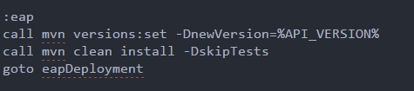

Figure20. EAP Versioning Configuration

Finally we specify the version value as a variable in run.bat file:



Figure21. Run.bat Version Configuration

After running the application, we can see the versioning configured as soon we hit the URL. The URL is now http://localhost:9090/v1.shoppingApplication/.

# Middleware connectors and ESB integration

Why do enterprises deploy APIs? Typically, this is done to allow internal or external consumers simplified access to enterprise backend systems. Often the API provides a front-end that accesses multiple systems on the backend. A sample use case might be for a store that receives new products and inventory from their suppliers. The steps for this might be:

1. receive new product and inventory information
2. store the product information in the product master data repository and create a new SKU (Stock-Keeping Unit – a unique identifier for products in a catalog or store)
3. add the SKU and inventory to the ERP (Enterprise Resource Planning) system
4. add the SKU into the CRM (Customer Relationship Management) system

All of these interactions could occur with just a single call to an API. How is this possible? By leveraging an Enterprise Service Bus (ESB) to integrate and orchestrate across multiple systems. As well an ESB can also do complex data protocol transformations to ensure data is formatted properly for each of the systems noted above.

JBoss Fuse provides an ESB - a lightweight standards based, loosely coupled platform. By relying on standards, the JBoss Fuse reduces the chances of vendor lock-in. By advocating loose coupling, the Fuse ESB reduces the complexity of integration. This section will demonstrate how easy it is to leverage the JBoss Fuse to build an orchestration across multiple back-end systems.

In our shopping application, we have a use case similar to the one described above: add product and inventory. This will be somewhat simplified, but still demonstrate the power of the ESB. Figure 23 shows the camel route that has been developed. In this example, we retrieve the incoming add product request from an activemq queue, we log the information, we load the product into a SQL database, and then we both add the product to our Salesforce CRM system, and also tweet the product addition on Twitter.

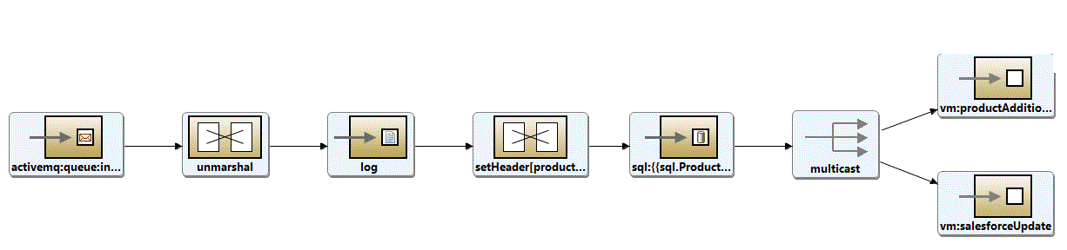

Figure . Camel route for adding products and inventory

Note: See the shopping cart application for a larger view

In subsequent sections, we will discuss in more detail how this route gets called via a web service, as well as how the interactions with Salesforce.com and Twitter occur. For now, we will focus mainly on the basic routing functionality.

**Understanding the interaction with beans wiring:**

Below are the beans used to create the AddProducts functionality . These beans are available at OSGI-INF/beans.xml. Since all the files in OSGI-INF folder are loaded in fuse the beans are created on deployment.

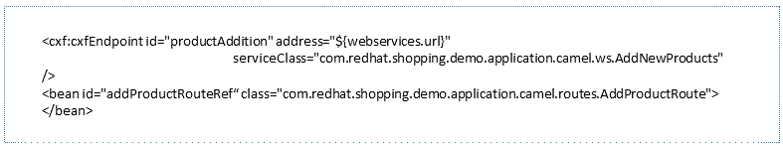

Figure . beans.xml

The beans are set with values read from the configuration file {server.home}/etc/com.redhat.application.cfg. This configuration file location and some default values for the properties are in OSGI-INF/allCamelRouteBuilder.xml

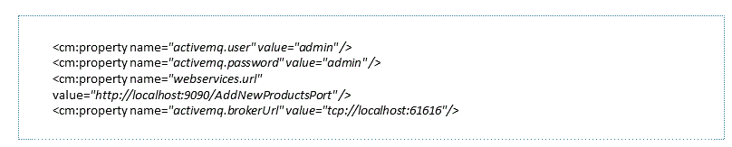

Figure . allCamelRouteBuilder.xml

Finally the addProducts bean is added to a camel context where we are specifying it as a camel route. This configuration is done in OSGI-INF/allCamelRouteBuilder.xml.

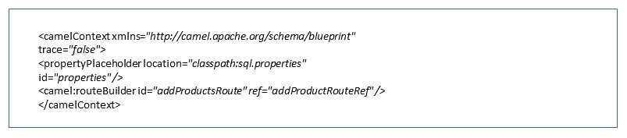

Figure . allCamelRouteBuilder.xml (continued)

**Data-Source Used:**

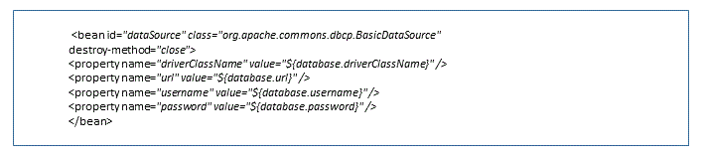

Figure . beans.xml

To further explain the values of username and password we will show the values from beans.xml. We will see the jdbc connector used in database.url property.

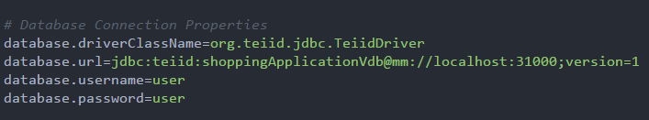 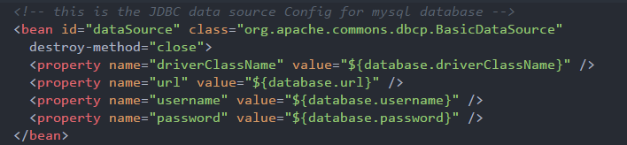

Figure . shoppingApplication.properties and beans.xml

**Middleware Connectors:**

There are a number of connectors, which Fuse ESB provides but will be referring to the ones we have used in our Shopping Application. Following are the connectors used:

|  |  |
| --- | --- |
| Connector | How it is used in our Shopping Application |
| File | See Section 4 |
| JDBC | See Section 4 |
| Twitter | See Section 7.3 |
| Salesforce | See Section 7.2 |
| Jetty | See Section 2 |
| Gauth | See Section 2 |
| Bean | See Section 2,4,6,7 |
| SQL | See Section 4 |
| CXF | See Section 4 and 5 |
| ActiveMQ | See Section 7.1 |

# API for Independent Web Services

APIs can be simple RESTful services, or they can be the more traditional WSDL-based SOAP services. In this section, we will discuss how to expose a SOAP service.

In the previous section, we built a camel route for adding products. This route accepted data on an inbound ActiveMQ queue. Now, we need to make this available as a web service so that it can easily be consumed outside the enterprise. Using JBoss tools, this is a simple endeavor.

First, we need to develop the below AddProductRoute component. Note that in the example below, we are loading products from the local server to simplify the example. In an enterprise implementation we would use a different approach for loading products.

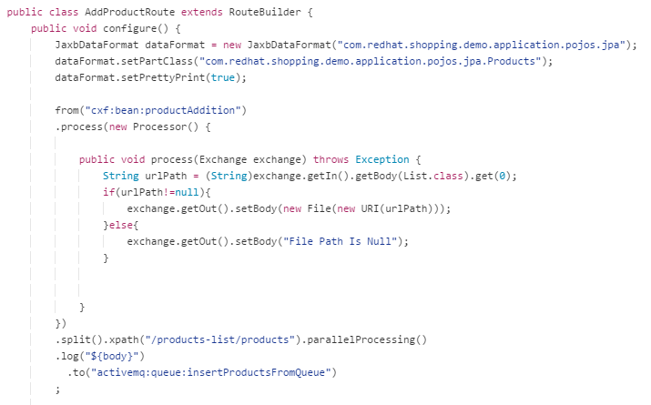

Figure . AddProductRoute

1. In the Add Product route we configure our starting endpoint in beans.xml as a cxfEndpoint with an address of webservices.url which is defined in camel-javaRoutes.xml as http://localhost:9090/AddNewProductsPort.
2. We move on to processor under the process () function. The String urlPath get its value when the web service is called, where the user adds the URL in argument which he wants to send to the web service. For shoppingApplication this URL is the reference URL of xml which contains the products lists. For reference we can see figure 13 below.
3. This URL is transformed into a File Object for an easier split up.
4. In the xml file we have parent tags as <products-list><products>..{product info tags}.. . Hence to traverse the product details tags we split through the xpath containing our parent tags.
5. After the split is done we log the product details retrieved from xml in body and reference to the endpoint of ActiveMQ queue . The products are sent individually to the queue.

To test all of this, we recommend using SoapUI[14], a simple graphical editor where one can create a WSDL,project and add an existing WSDL to generate request/response structure. The wsdl for our application is located at application-interface\..\resources\wsdl\AddNewProductsService.wsdl. No we can create and execute sample requests for all the operations in the service. Our approach for this is shown in Figure 30 below. The shopping application has test XML files available for adding products as well.

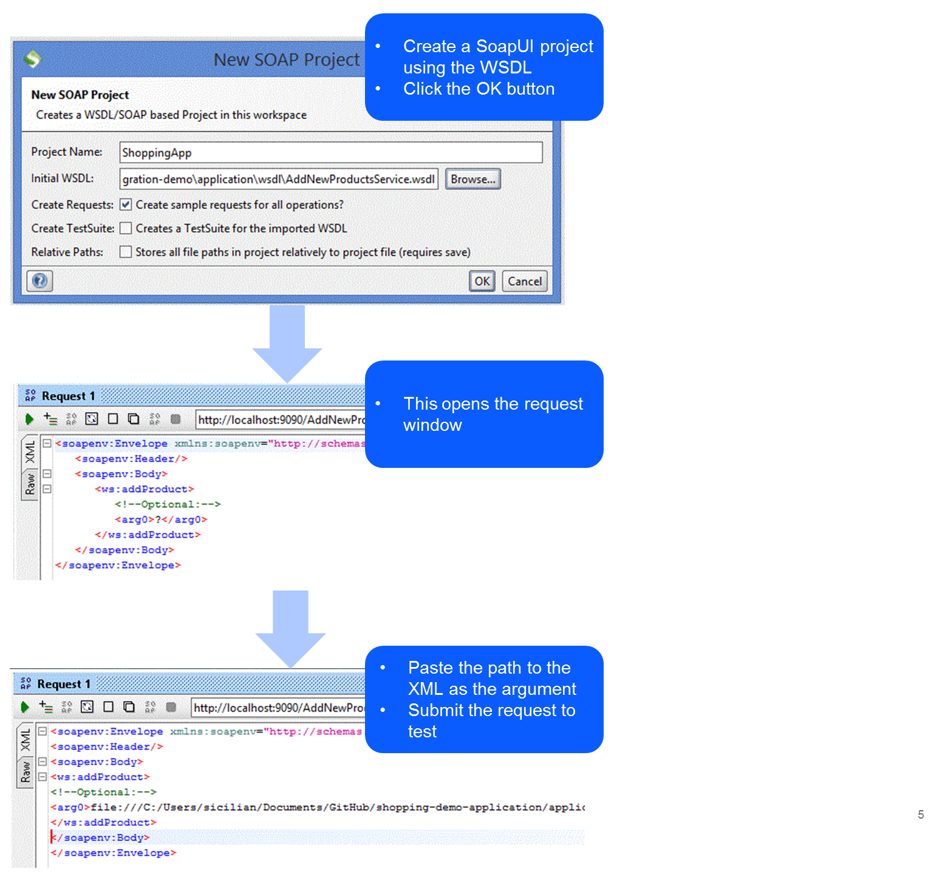

Figure . Testing the Web Service using Soap UI

A sample xml file containing the products is shown below:

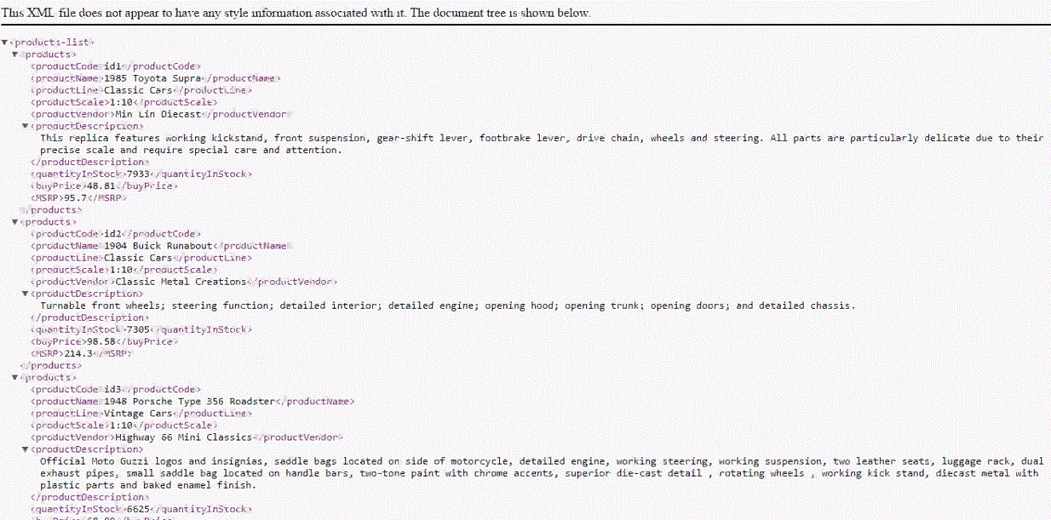

Figure . XML file containing the products details.

*Note: See the shopping cart application for the actual file details*

# Mediation – Message Validation, Message Transformation

**Message Validation** is confirming the validity of messages. It's concerned with message level validation and not business level validation. It can validate messages to their schemas, but not executing any business rules on messages.

We have implemented a use case in our shopping application in which the “buy product” requests are validated and then executed. If the user credentials are not provided in the request then the validation fails and a validation exception is thrown which provides an appropriate message to the user, else the request is processed further.

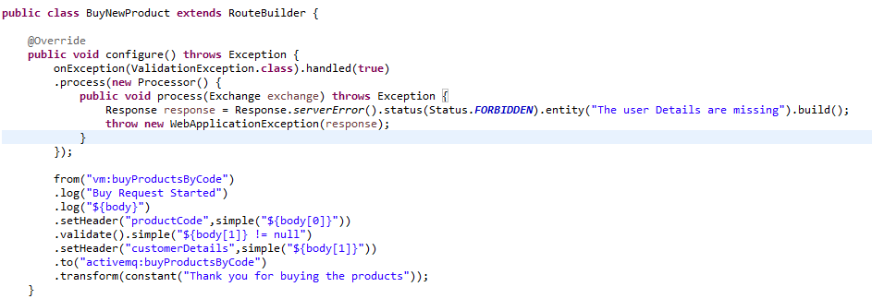

 Figure . BuyNewProduct.java Using Camel Validation Procedure

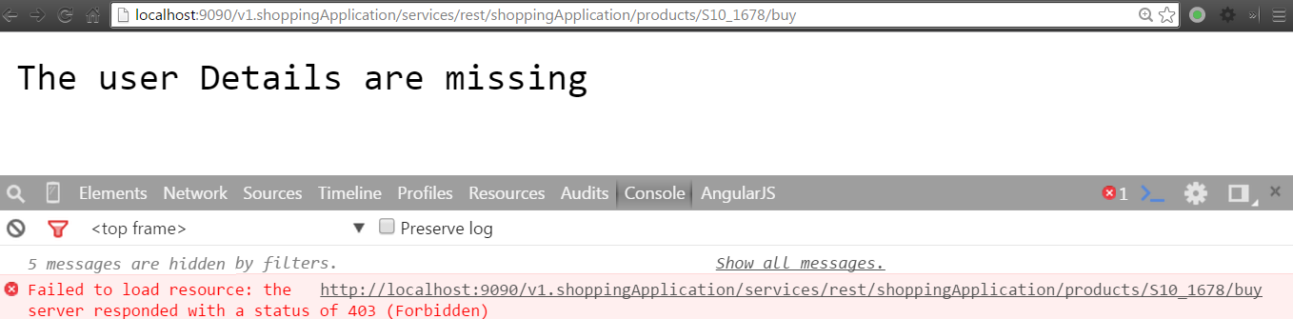

 Figure . Validation Failure Message

The dynamic router in the rest server is another implementation of our shopping application which validates incoming request:

1. The endpoint cxf:rsServer is configured with the address of <http://localhost:9090/route>
2. Upon hitting this URL the dynamic router, which is surrounded by method reference of restRouteProcessor ,calls it.
3. RestRouteProcessor implements the Processor class which sets the values of the exchange object headers as per the operationName. This Processor is being watched over by a Rest Service ShoppingHomeService. This service includes the annotations of @Path , @Produces and function name.
4. Whatever the path, a user hits after the cxf:rsServer URL, that path is being validated first in ShoppingHomeService class and the RestRouteProcessor sets the Operation Name according to the function called in rest service as per its path.
5. We will show the flow and snippets of ShoppingHomeService and RestRouteProcessor which explains our use case.

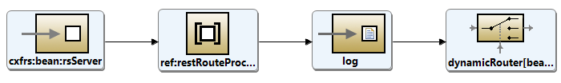

Figure . RestServiceFlow

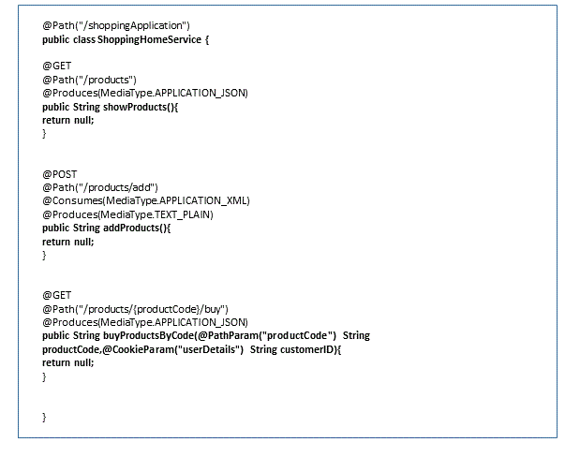

Figure . ShoppingHomeService to depict our rest service watching over the processor.

We can see the Shopping Application specifies when to return a JSON or a XML and by what path and its function name which is being validated.

**Understanding the RestRouteProcessor:**

RestRouteProcessor get its Operation Name(method) after the ShoppingHomeService responds.

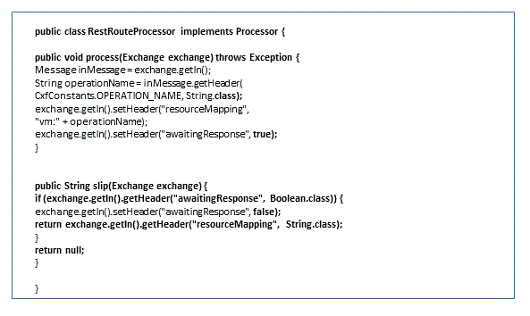

Figure . RestRouteProcessor

**Message Transformation:**

**Message transformation** is modifying the format of the message from one type to another. (e.g.: from XML or text, json). It is used to modify the type of message required from one system to the type required by another system. It can also be used to transform the content (body) of a message the consumer sends to match the content of the provider. (e.g.: date format MM:DD:YY to DD:MM:YYYY)

Message parsing and formatting services provide the ability to manipulate messages into different formats, based on the message structure. This is a syntactical transformation of the data, based generally on technical considerations such that the message is more usable to receiving systems.

Message encryption services provide confidentiality of information, both while in transit, as well as when stored. Other technologies for confidentiality such as secure sockets layer (SSL)/transport layer security (TLS) or virtual private networks (VPNs) only provide confidentiality while the information is in transit, not while it is stored at a server.

We have applied the concept of message transformation in many routes. Below is an example for the same. We are displaying all the *Product* objects from SQL and transforming it to JSON as we need to produce a JSON response for the rest service. The result is displayed as an html table in the application page. See the figures below for details.



Figure . camel-showProducts.xml

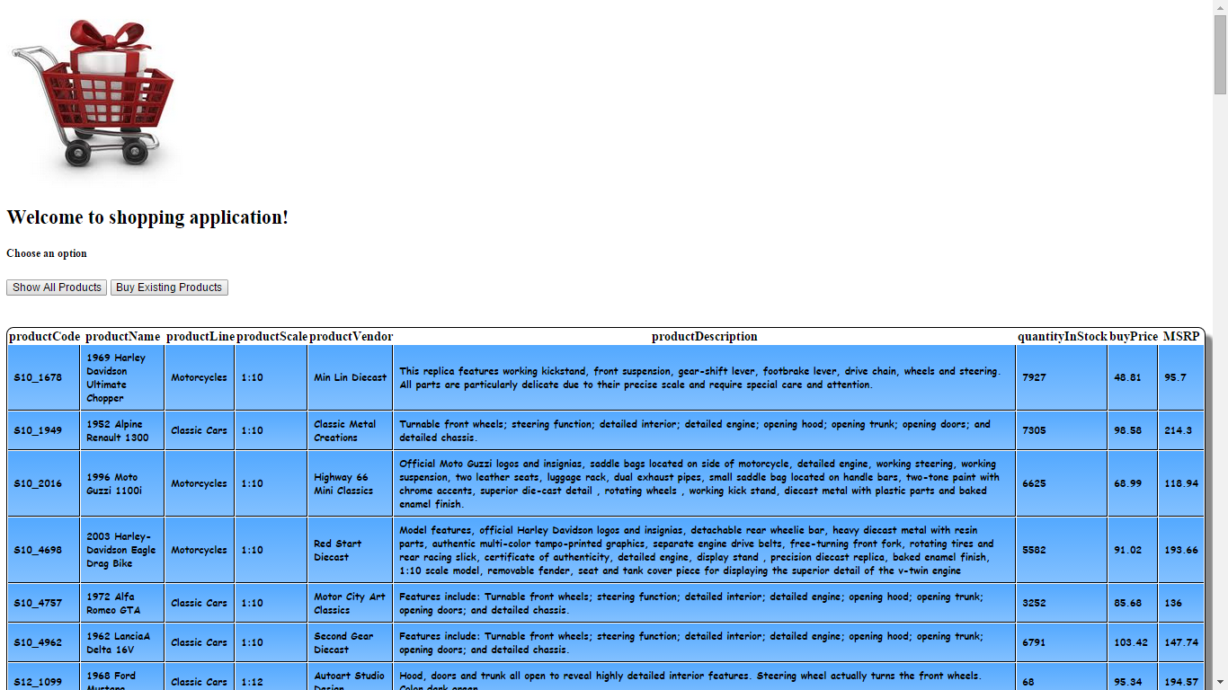

Figure .Result of the SQL to JSON displayed in the application

# Productization –Third party API integration

Use the API platform to orchestrate internal and third party APIs to create new mash up APIs that can power new business services and applications. Use the API platform to refactor backend API services and data sets to be more users centric.

## A-MQ Connector

Fuse easily consumes and publishes messages from JMS queues or topics. The ActiveMQ component allows messages to be sent to or consumed from a [JMS](http://java.sun.com/products/jms/) Queue or Topic.

**Understanding the interaction of AMQ Connector with the Shopping Application**

We are unmarshalling the *Products* which were inserted in queue. As per the camel route we can see that we set the headers as per the *Product* fields. After setting the values they are sent to the database via the addProducts query. After the query is executed the *Products* are sent to the twitter and salesforce endpoints.

For understanding the flow of the ActiveMQ camel route, we will again show the figure below to understand the concept of its flow:

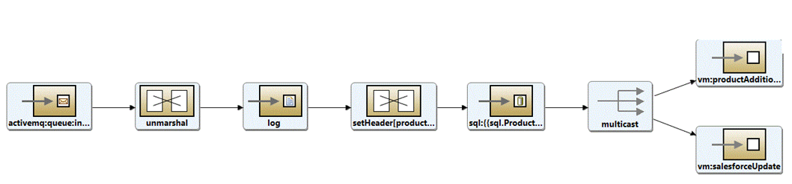

Figure . Add product camel route

Below we have mentioned the ActiveMQ camel route, which explains how the products have been given values and how they are sent from amq queue to sql update query.

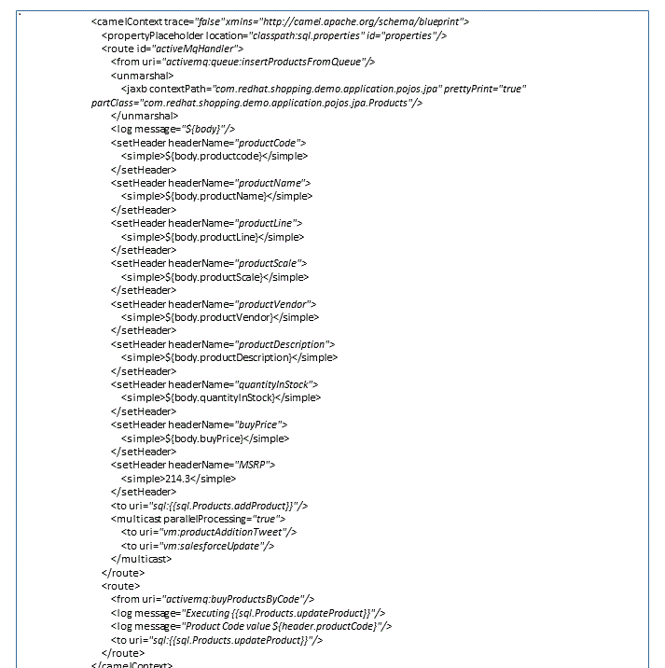

Figure . camel-activemqRoutes.xml

## Salesforce

Fuse easily interfaces with Salesforce API's for inbound as well as outbound. This component supports producer and consumer endpoints to communicate using Java DTOs. There is a companion maven plug-in, Camel Salesforce Plugin, that generates these DTOs. Two DTOs were generated namely ProductsObject_c and QueryRecordsProductsObject_c. ProductsObject_c shows only ProductName and ProductPrice.

**Understanding the interaction of Salesforce Component with Fuse:**

We are basically updating the Exchange object with new values as we need to show only *ProductName* and *ProductPrice*. Using camel-salesforce route we update the new values of Exchange Object to Salesforce site. Below we are showing the flow, which works in camel router:



Figure . Camel route to insert product into Salesforce (MulticastInsertion:Salesforce)

**Understanding the beans wiring in Salesforce:**

Below are the beans we have created to use salesforce functionality. These beans are available at OSGI-INF/beans.xml. Since all the files in OSGI-INF folder are loaded in fuse the beans are created on deployment.

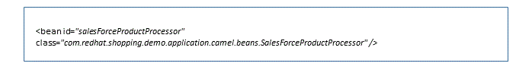

Figure . beans.xml

Below is the class of the ProductsObject:

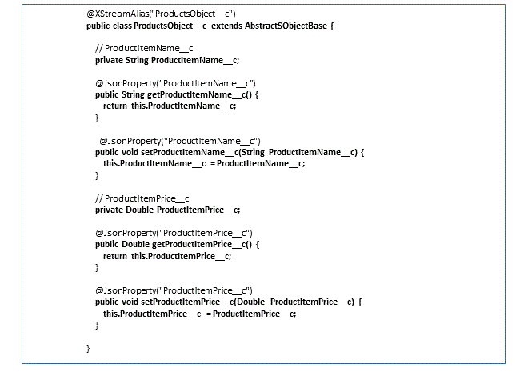

Figure . ProductsObject

**Understanding the Router:**

In the SalesForceProductProcessor we are replacing the original exchange object containing all the product's data to the exchange object containing only two fields i.e. name and price.

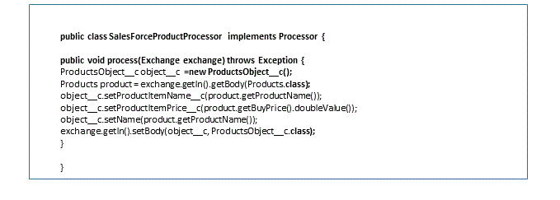

Figure . SalesForceProductProcessor

Finally in the camel-salesforce route we can see how the values are updated in salesforce.

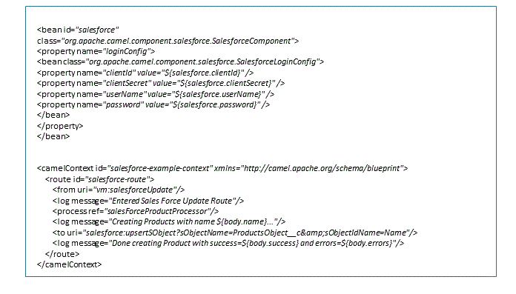

Figure . camel-salesforce.xml

When this is executed, you can see the result in your salesforce instance:

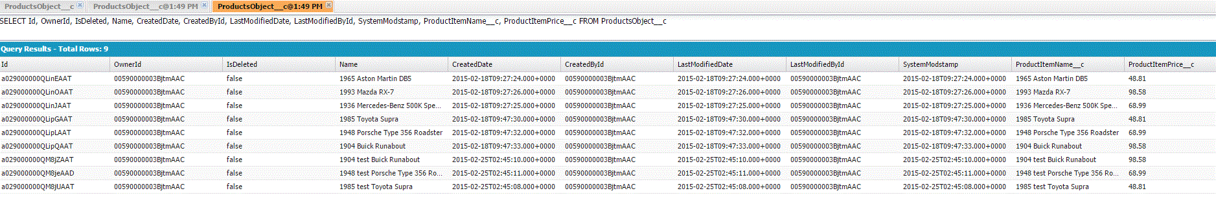

Figure . Results in SFDC

## Twitter

Fuse allows direct, polling, or event-driven consumption of timelines, users, trends, and direct messages using the Twitter API.

The Twitter component enables the most useful features of the Twitter API by encapsulating [Twitter4J](http://twitter4j.org/). It allows direct, polling, or event-driven consumption of timelines, users, trends, and direct messages. Also, it supports producing messages as status updates or direct messages.

Twitter now requires the use of OAuth for all client application authentication. In order to use camel-twitter with your account, you'll need to create a new application within Twitter at https://dev.twitter.com/apps/new and grant the application access to your account. Finally, generate your access token and secret.

**Understanding the interaction of Twitter Component with Fuse:**

We are showing below the flow in which twitter component works: Here we are basically converting the products which were added during sql query (more explanation about product addition can be seen in Section 4) are being transformed to String and then tweeted on the timeline of the user logged in.

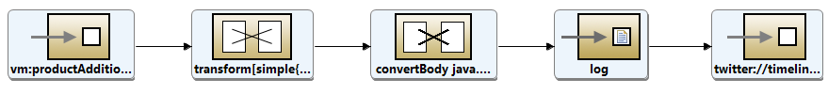

Figure . MulticastInsertion-twitter

This configuration below is necessary for the twitter component to allow it for polling and tweeting for the application.

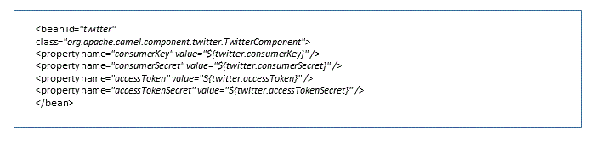

Figure . beans.xml for Twitter

When this is executed, the application automatically generates a tweet upon each product creation.

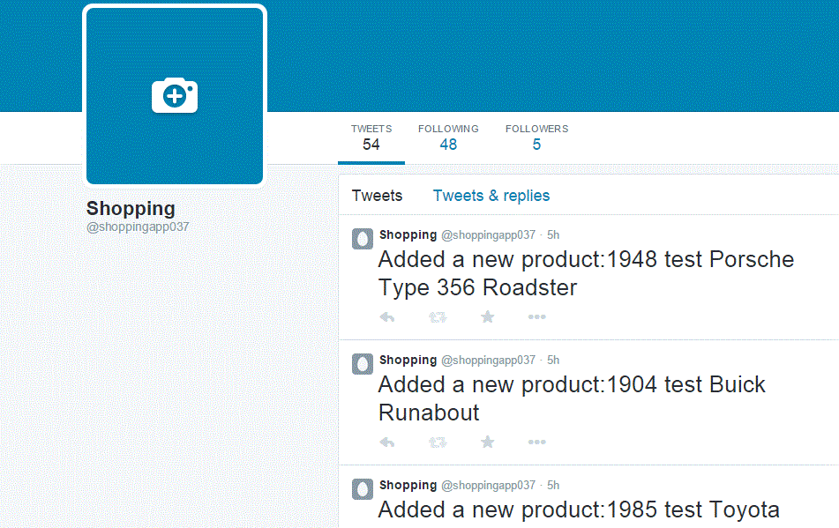

Figure . Twitter feed when products are inserted

# Certification and testing

Team needs to be accountable for defining the testing methodology for the development factory/team. Typical scenario is to define unit test cases prior to even starting build activities. Those test cases are used to drive detailed requirements and build. That establishes processes & guidelines to ensure that unit / integration / consumer acceptance testing coverage is sufficient depending on API classification/type. Set requirements on regression testing and performance testing deployment gates that guides subsequent testing processes.

API hierarchy of needs –

1. Usability - Is it easy to set up?
2. Functionality - Does it work as expected / documented?
3. Reliability - Is it “reliable” over time?
4. Proficiency - Does it increase the developer's skills?
5. Creativity - Can it be used in new ways?

Putting more effort into API testing, can leads to a much healthier final product. Ensuring that all data access (read and write) goes only through the API significantly simplifies security and compliance testing and thereby certification, since there is only one interface.

Ensuring that all the required business rules are being enforced at the API tier allows time for much more complete user-experience tests once the UI is released, and not having to concentrate on testing every single business rule and path through the application near the end of the project. Ensuring that the API offers complete functionality allows for easy future expansion of the application as new business needs arise.

JBoss tools comes with camel plugins which make testing quite easy. We can create a test suite and configure test scripts to be executed depending upon the requirements. The test scripts can be executed periodically and also on every new commit in the git repository. JBoss tools can be easily integrated with Jenkins to automate the build and deployment cycle of the API services.

# Data services – Direct data access, Meta data services

JBoss Data Virtualization (JDV) allows for an application to implement a virtual layer so that multiple data endpoints act as a single data source within the application. Some key benefits include:

* Expose data through a single uniform interface. Data sources can be txt,csv or different database server
* Data from different sources can be handled by a Rest Service.
* JDV provides a platform to access data using the same query language irrespective of the database server. The data handling implementation is handled by JDV which decouples data handling code in the API level and the data configuration. The feature facilitates in API development a lot. Using JDV as the data management server the overhead of managing different drivers and protocols for accessing different data sources is not to be implemented in the API.
* Expose legacy data sources as data services. Since JDV exposes all its data sources by a REST service and by a query language. The feature supports easy implementation to handle data at API level.
* Provide a uniform means of exposing/accessing metadata
* Provide a searchable interface to data and metadata
* Expose data relationships and semantics
* Provide uniform access controls to information

For our shopping application, we chose to create a virtualization layer that allows the application to interact with two data sources (MySql and Postgres) through a unified interface. The JDV server seamlessly forwards all the SQL calls to the proper data source.

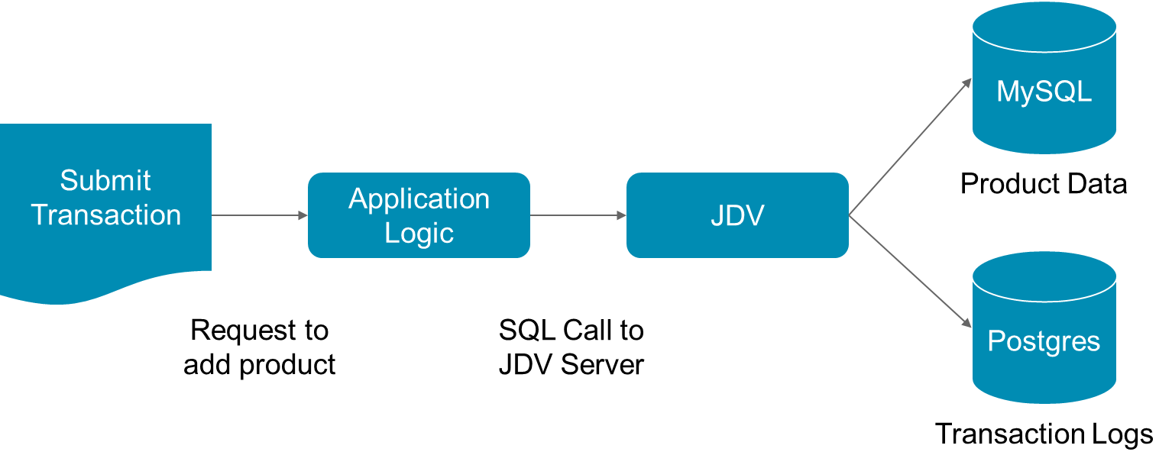

Figure . JDV Usage in the Shopping Cart Application

The steps to create this are very simple using JBDS. These steps are illustrated in the figures below.

1. Create a Teiid project
2. Create the MySQL data model
3. Create the PostreSQL data model
4. Create a virtual database that exposes these two models as a single datasource to your application

First we will create the MySQL data model.

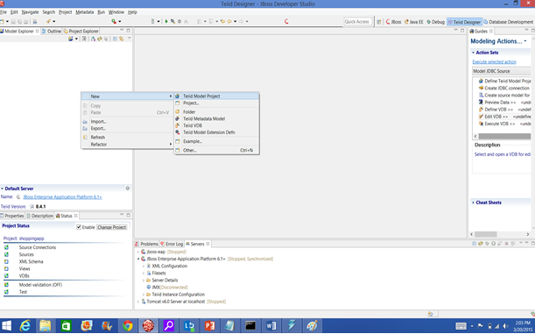

Figure . Creating a Teiid Model Project

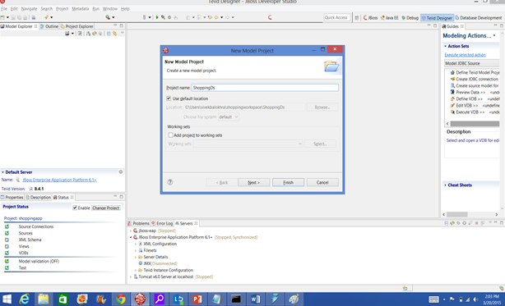

Figure . Creating the new Model Project

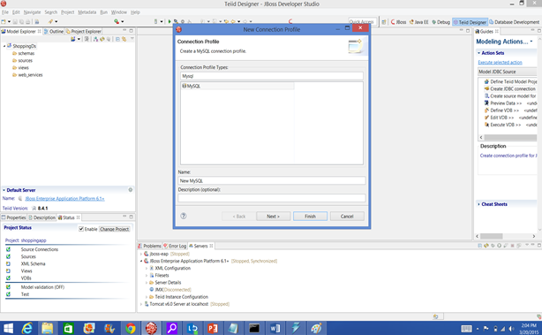

Figure . Creating a new JDBC connection and configuring MySQL

After configuring the connection details with its respective username and password we click on Finish.

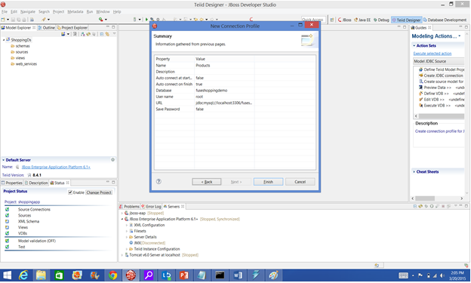

Figure . The completed MySQL datasource

We can now view the data model for the MySQL connection. The source model of the fuseShoppingDemo database now shows us the UML diagram of products with their fields.

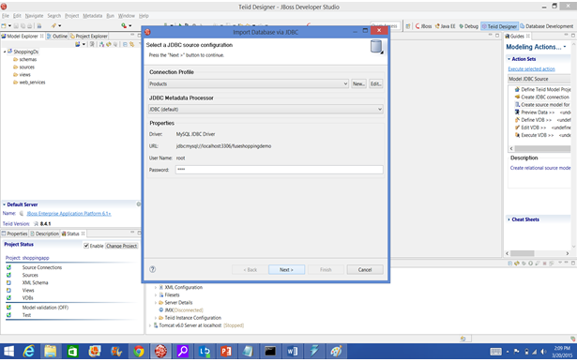

Figure . Select the MySQL data source

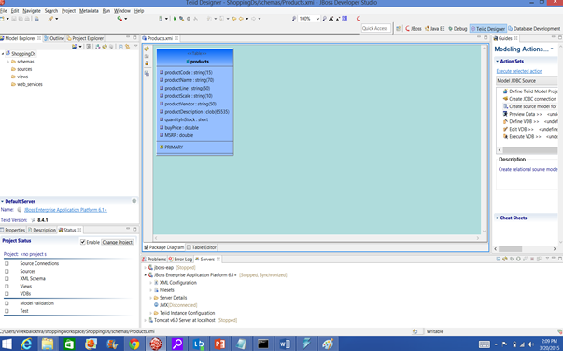

Figure . Viewing the source model of the fuseShoppingDemo database

Since we are creating a virtual database across two different data sources, we now need to follow the same steps for a PostgreSQL data source. We follow the same steps as for MySQL to create a new connection and view the source model. After connecting to the Transaction database in PostgreSQL, we can see the source model in the figure below.

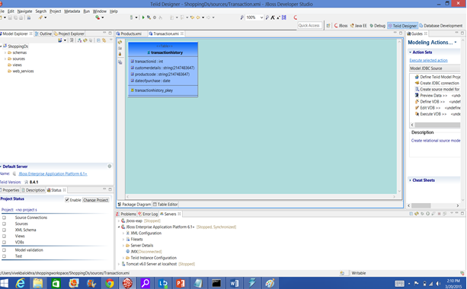

Figure . Viewing the source model of the Transaction database

Now that the underlying databases are configured, the next step in creating a virtual database is to go to the File Menu and create a new Teiid VDB.



Figure . Creating a new Teiid VDB

The new VDB asks for models. We simply click on the Add button to add these to our VDB.



Figure . Adding the previously created models

The virtual database ShoppingVDB.vdb is now ready for use.



Figure . The newly created ShoppingVDB.vdb

To use this in the Shopping Cart Application, we need only configure the application to use the VDB as it would any other data source, using the Teiid JDBC driver:

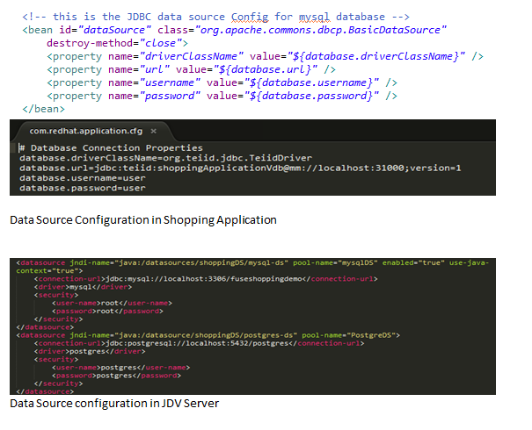

Figure . Data Source configuration in Shopping Cart Application

We also must configure JDV to point to both MySQL and Postgres:



Figure . Data Source configuration in JDV

Now that this is configured, our application can expose the data as XML, ODATA, or JSON. These are shown in the screenshots below.

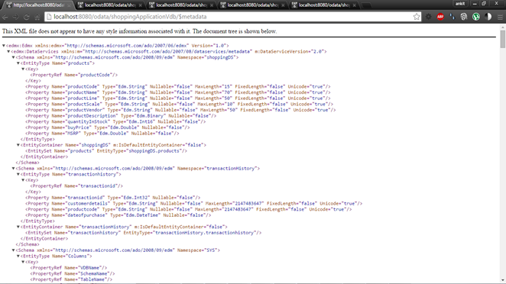

Figure . XML view of the Shopping Application metadata

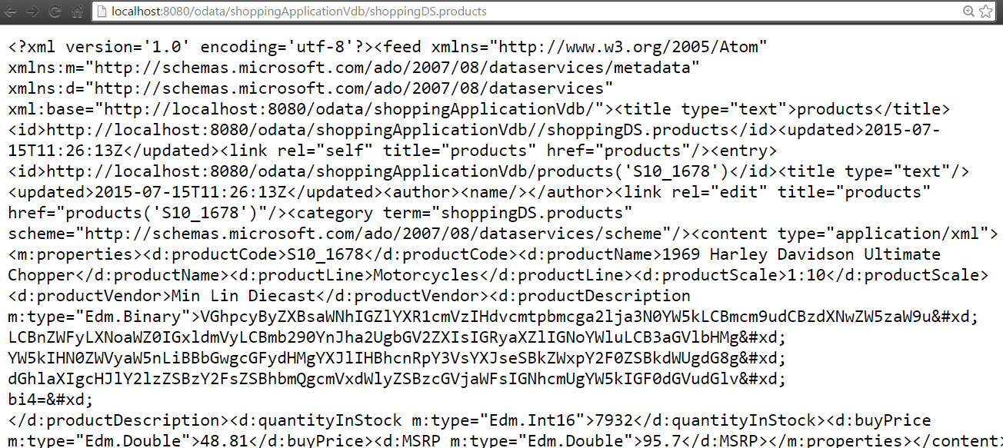

Figure . Products exposed as ODATA

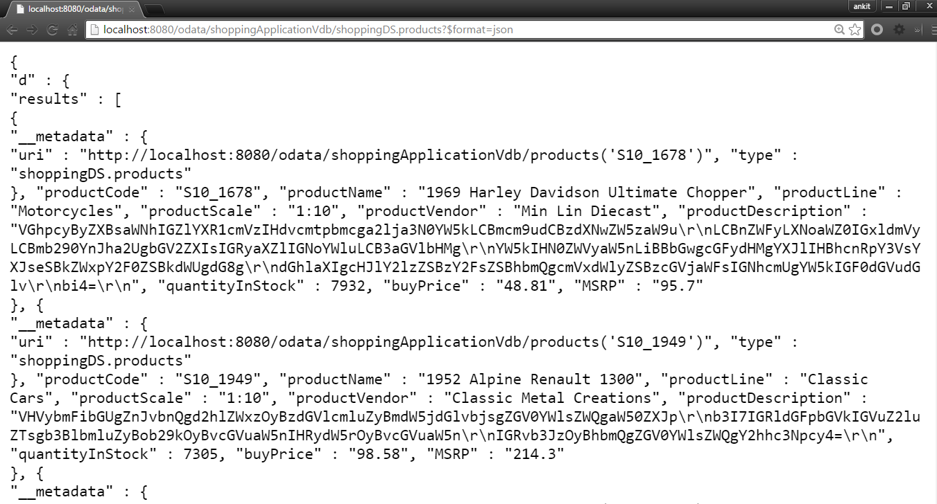

Figure . Products exposed as JSON

# Business intelligence

Leverage API platform to track and record every transaction for auditing and debugging. Enable real time monitoring to diagnose system performances and transaction issues.

**Logging and Audit Tracing:**

Logging and Audit Tracing Services permanently store application information in a data store that can be later accessed for operations management.

Typically, Logging and Audit Tracing Services are used to:

* Keep track of technical failures.
* Monitor the load of a server or the use of an application.
* Document the use of sensitive application or system privileges. (Creating new users, etc.)
* Store transaction and digital signature data for non-repudiation purposes.

In our Shopping Application we have used logging in various sections and have logged the events in our server log file located at jboss-fuse-6.1.0.redhat-379\data\log.

We have also created a class known as LogProductFetchTime which logs the time while showing products. This class is using the camel aop mechanism to fetch the time taken by the sql query.A screenshot of the class can be shown:

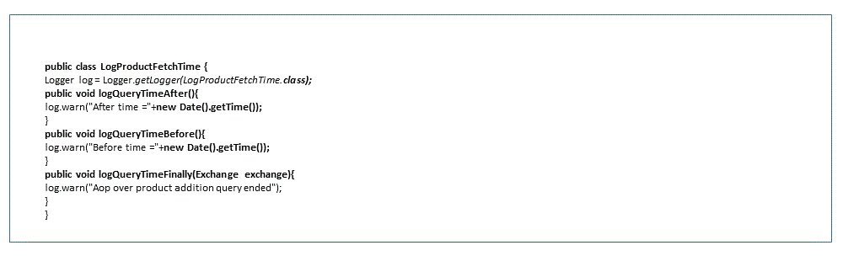

Figure . LogProductFetchTime

We have used log4j for logging and it can be configured by modifying the log4j.properties file. The log4j properties file is available in the resources folder of the project.

# Feedhenry Integration:

The Red Hat Mobile Application Platform (formerly FeedHenry Mobile Application Platform) brings agility, visibility and efficiency to enterprise mobility. This mobile app platform embraces collaborative app development. The platform allows for easy integration of back-end APIs to develop and deploy native mobile applications.

Building a mobile application on Feedhenry is out of the scope of an integration whitepaper. However, we felt it was important to demonstrate the ease of integration between Fuse and Feedhenry.

For our purpases, we are using the feedhenry environment to deploy an angular based application. This application is capable of consuming all the services that have been created in the shopping application.

The screenshots below will demonstrate how feedhenry is helping to create a frontend to display the products of shopping application on cloud.

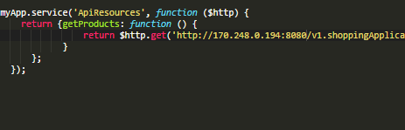

Figure .Angular Service Consuming API as a REST service

The front end application is created and we have created a service to retrieve all the products using the api. The service here is using the angular http module to make a get request on <http://localhost:8080/v1.shoppingApplication/services/rest/shoppingApplication/products> which returns all the products.

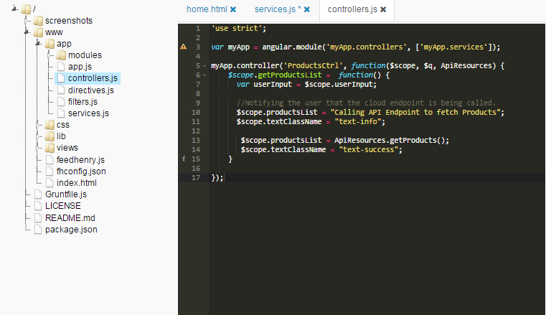

Figure . LogProductFetchTime

This service is used in a controller which maps the data retrieved to a model object.

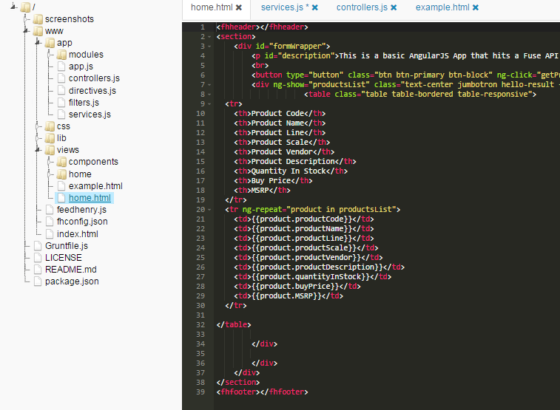

Figure . HTML file with angular directives to display products as a table

Finally the model is displayed on an html page.

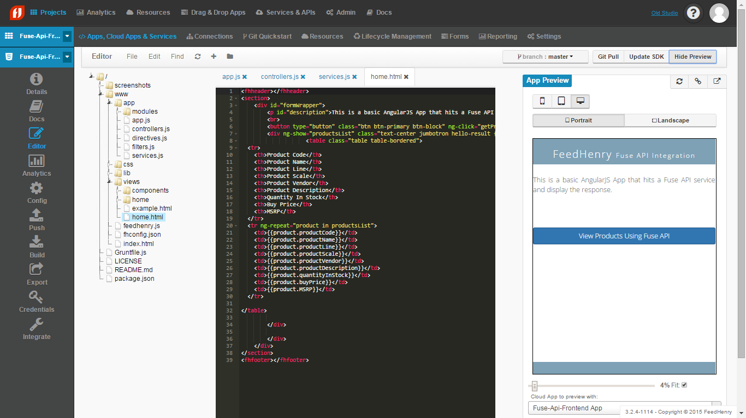

Figure . Feedhenry console with the quick view of the angular app

The results can be viewed using the feedhenry application preview panel. Above is the homepage which displays a button to view the products in the shopping application.

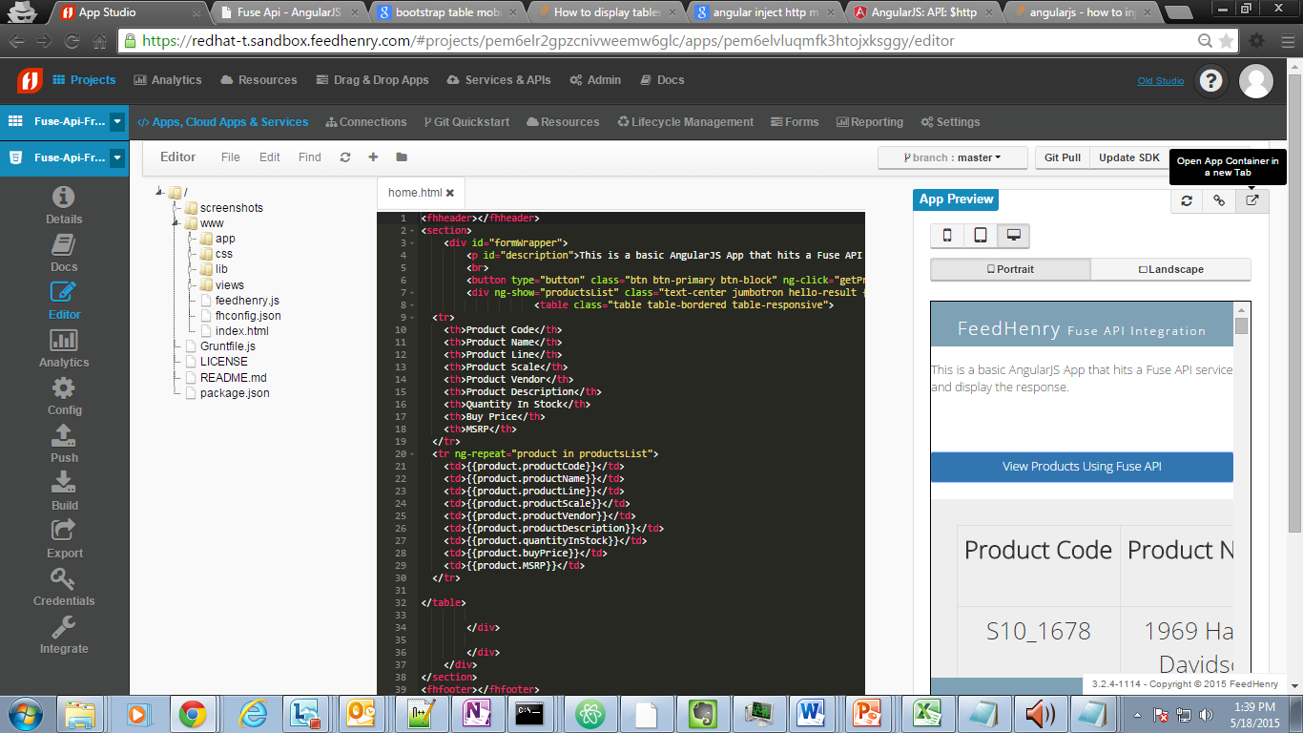

Figure . Products being displayed in the feedhenry console

Once the button is clicked the controller is invoked which uses the service mentioned above to populate data from the API.

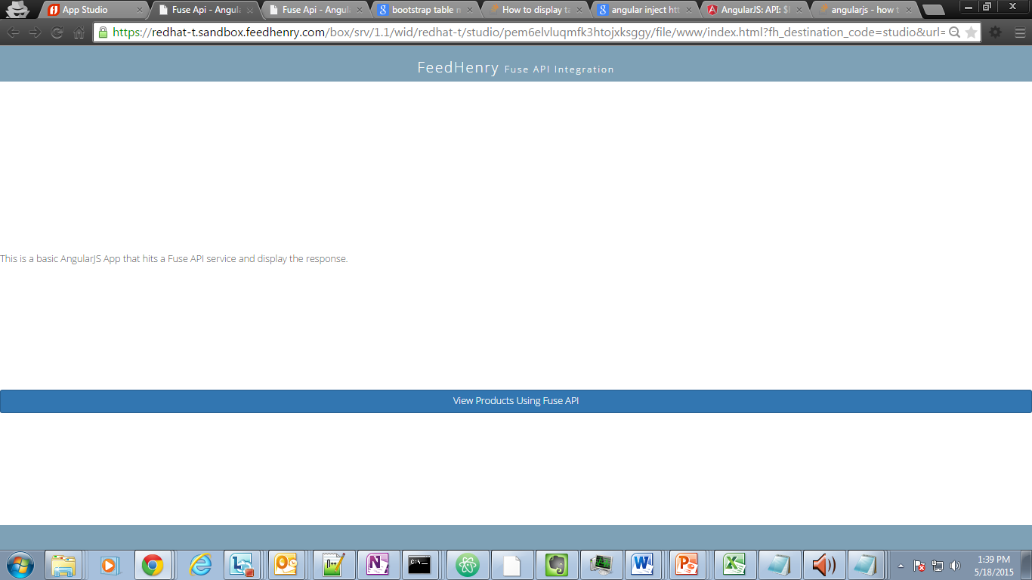

Figure . Full window view of the angular app

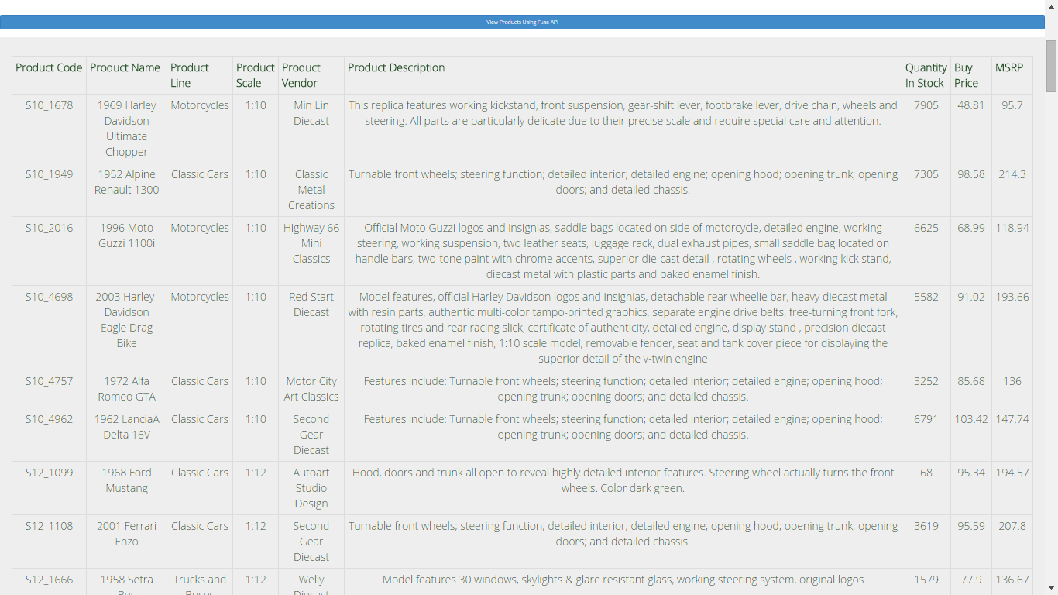

Figure .Products list displayed by angular app

The results can also be viewed in a separate window and not in the app preview panel. As you can see, pulling data from a REST API can be performed easily in Feedhenry, allowing for a simplified approach to mobile development.

# Appendix

All of the steps required to deploy and run the application on JBoss EAP and Fuse are documented in Github. Browse to the repository located at <https://github.com/jbossdemocentral/fuse-dv-shopping-integration-demo>. The Readme.md file (<https://github.com/jbossdemocentral/fuse-dv-shopping-integration-demo/blob/master/README.md>) contains detailed instructions.

# References

Copyright © 2015 Accenture

All rights reserved.

Accenture, its logo, and

High Performance Delivered

are trademarks of Accenture.

1. Shiro Security: <http://camel.apache.org/shiro-security.html>
2. Spring Security: <http://camel.apache.org/spring-security.html>
3. XMLSecurity DataFormat: <http://camel.apache.org/xmlsecurity-dataformat.html>
4. XML Security component: <http://camel.apache.org/xml-security-component.html>
5. Crypto DataFormat: <http://camel.apache.org/crypto.html>
6. Crypto component: <http://camel.apache.org/crypto-digital-signatures.html>
7. Jetty: <http://camel.apache.org/jetty.html>
8. CXF: <http://camel.apache.org/cxf.html>
9. Spring Web Services: <http://camel.apache.org/spring-web-services.html>
10. Netty: <http://camel.apache.org/netty.html>
11. MINA: <http://camel.apache.org/mina.html>
12. Cometd: <http://camel.apache.org/cometd.html>
13. JMS: <http://camel.apache.org/jms.html>
14. SoapUI: <http://www.soapui.org/>